**Assignment 19.3**

**Problem Statement:**

Task 8: Write a MapReduce program that takes the output of Task 5 (refer session 7, assignment 1) as input, and produce output which is sorted on the total units sold. You may use a single reducer for the sorting. Use Sequence File formats as output of Task 5 and as input for this task.

**Program:**

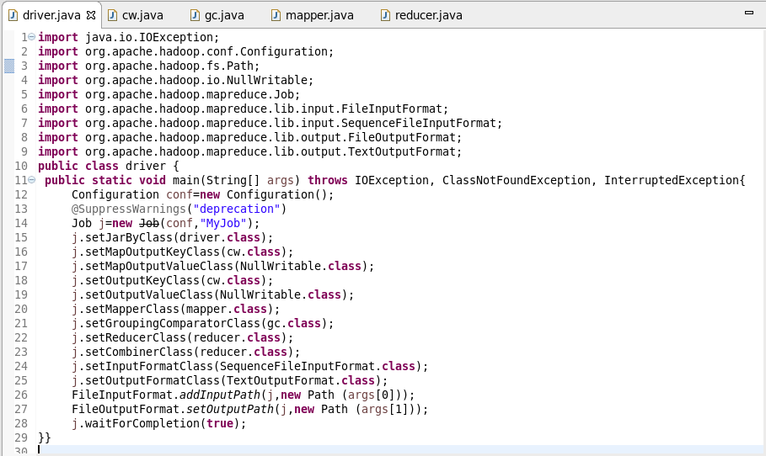

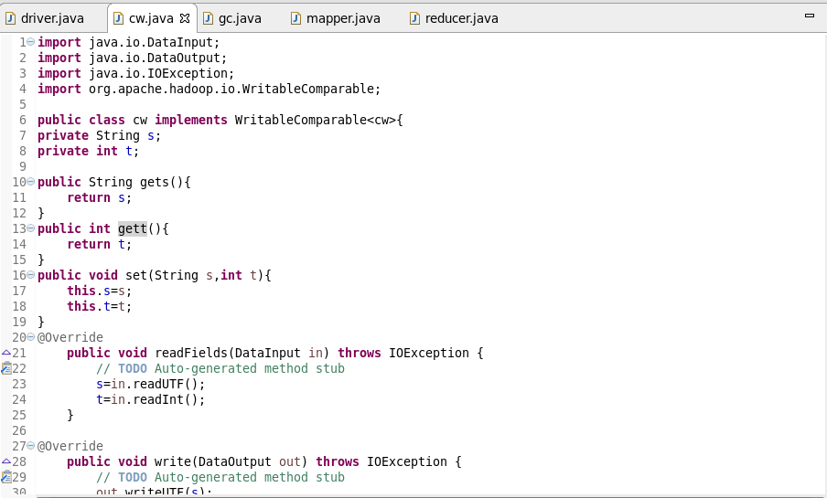

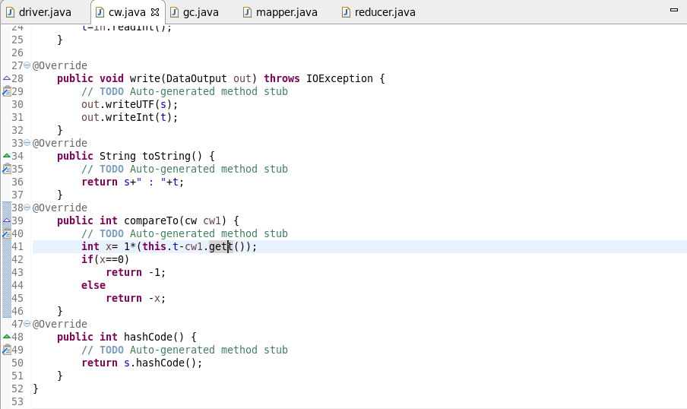

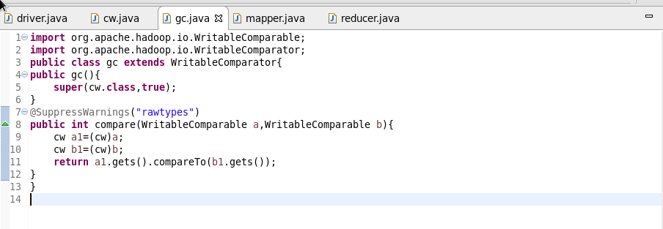

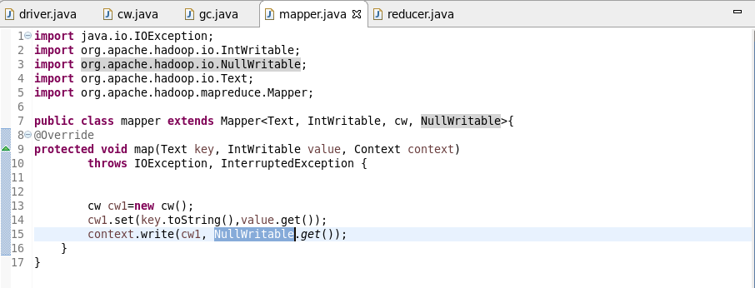

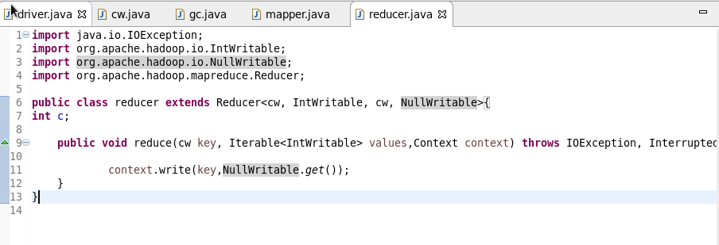

**Output:**

